CYB 300 Module Four Lab Worksheet Two

Andree Salvo
Southern New Hampshire University
CYB 300-14668
Instructor: Jason Keltner

Lab: Manage Certificates

Exercise 1: Manage Certificate Templates
Prompt | Response
Task 1: Take a screenshot of step 8 showing the details of the new user cert template. Add your name in the command line. | 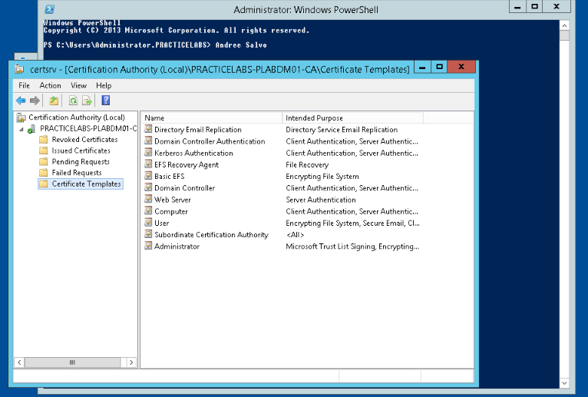

Exercise 2: Manage Certificate Enrollment
Prompt | Response
Task 1: In Step 4, replace the name in the “Template display name” with your last name -SecureUser (LastName-SecureUser).  Then, in Step 13, scroll down until you see LastName-SecureUser and take a screenshot of the Enable Certificate Templates window. | 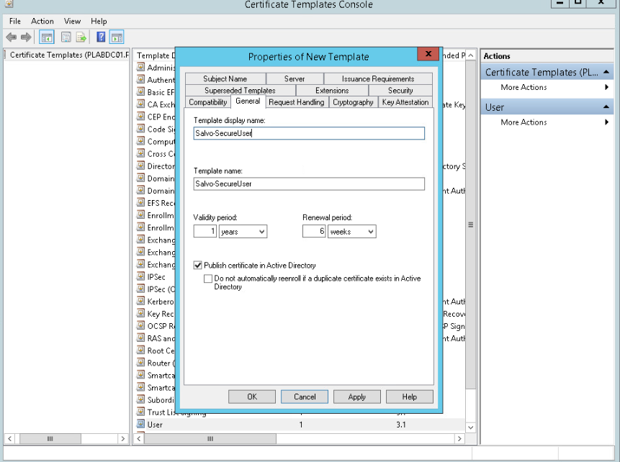  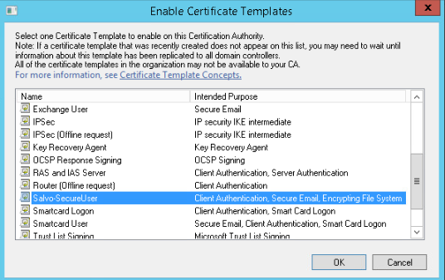
Task 2: In Step 10, run the gpupdate /force command to propagate the new user Group Policy to the domain. Add your name after the command prompt and take a screenshot of the output and your name. | 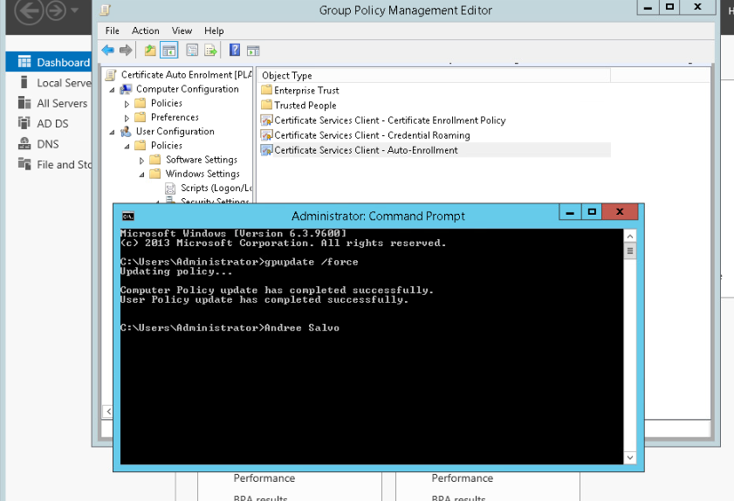
Task 3: In Step 10, take a screenshot of the Certificate Installation Results window. | 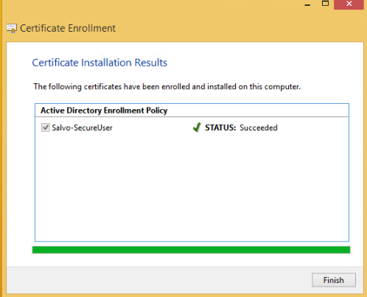
What is the importance of creating custom self-signed certificates for your organization? For example, are settings customized depending on the type or business of the organization? | The importance of creating a custom self-signed certificate let’s organizations control security settings like key strength, validity, and usage, tailoring them to business needs and compliance requirements.

